INFO 6008 - S2023 Assignment 3

Gihan Shamike Liyanage

1142109

IT Auditing

07/07/2023

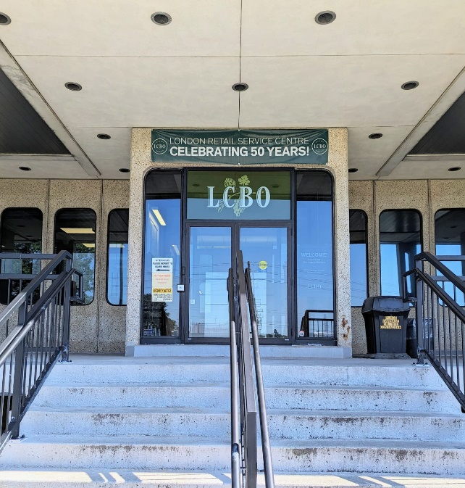**Location**: LCBO London Logistics Facility

**Address**: 955 Wilton Grove Rd, London, ON

1. What is physical security’s most important concern?

The protection of people, assets, and information against unauthorized entry, damage, theft, or harm is the main goal of physical security. By putting access control, monitoring (surveillance systems), alarm system, and trained security people into place, it seeks to establish a secure environment. Preventing unauthorized physical access and reducing hazards are the major objectives. This entails safeguarding buildings, regulating entry and exit points, putting security measures in place, and setting up emergency response procedures. The goal is to prevent possible threats, reduce vulnerabilities, and guarantee the security and wellbeing of people and property inside a physical location.

1. Can you give one example of a physical control that works as a deterrent for your location of choice?

All the doors are equipped with an electronic lock system that requires an authorized access card to open. Without a valid access card, individuals would not be able to enter the location. This physical control serves as a deterrent by restricting access to only those who possess the necessary credentials, and it helps to maintain the integrity of the location, enhances overall security, and ensures that only authorized personnel are granted access.

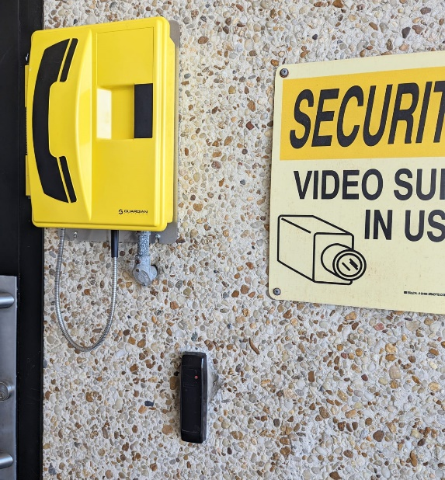

1. Do you believe the physical access control procedures are comprehensive for your location of choice? Explain your reasoning.

Yes, I believe that physical access control procedures at LCBO Logistics Facility are comprehensive because the facility is equipped with Perimeter security, Access control system, Surveillance system, Security personnel, Visitor management procedures and Alarm system. Other than that LCBO is a government-operated logistics facility that warehouses valuable assets and equipment, and it is known for upholding the highest industry standards, implementing best practices, and adhering to regulatory requirements.

1. Can you give an example of an environmental threat that could affect your location of choice?

Tornadoes are severe weather events that can damage warehouse structures, cause inventory loss, and pose risks to safety. The strong winds can lead to roof collapse and debris projectiles, while heavy rain and lightning can result in flooding and electrical hazards. To mitigate these risks, warehouses should have emergency preparedness plans with early warning systems, secure storage practices, backup power, evacuation protocols, and communication procedures in place. These measures help protect personnel, minimize damage, and ensure the safety and security of the facility.

1. Is there a major concern for physical security, for your location of choice? Explain your reasoning.

The facility likely takes extensive measures to ensure the protection of its assets and maintain a secure environment including robust access control system, surveillance system, security personnel, and comprehensive emergency response plan. LCBO is a government-operated logistics facility known for upholding the highest industry standards, implementing best practices, and adhering to regulatory requirements. Because of these I believe there are no major concerns for physical security at the facility.

1. What in your opinion is the primary tool for protecting people for your location of choice?

In my opinion, the primary tool for protecting people in any location is a comprehensive and well-implemented emergency response plan. This plan establishes protocols, procedures, and resources to effectively respond to incidents and ensure individual safety. It includes elements like clear communication channels, evacuation procedures, designated assembly points, training, and coordination with local authorities. A robust plan reduces panic, guides individuals during emergencies, and facilitates orderly evacuations, ultimately promoting preparedness and the overall protection of people in the face of various hazards.

